

***Fun Zone***

1. **Introduction**
2. **Objectives**
3. **Problem Statement**
4. **Hardware/ Software Requirements**

***Introduction***

The thirst for learning, upgrading technical skills and applying the concepts in real life environment at a fast pace is what the industry demands from IT professionals today. However busy work schedules, far-flung locations, unavailability of convenient time-slots pose as major barriers when it comes to applying the concepts into realism. And hence the need to look out for alternative means of implementation in the form of laddered approach.

The above truly pose as constraints especially for our students too! With their busy schedules, it is indeed difficult for our students to keep up with the genuine and constant need for integrated application which can be seen live especially so in the field of IT education where technology can change on the spur of a moment. Well, technology does come to our rescue at such times!!

Keeping the above in mind and in tune with our constant endeavour to use Technology in our training model, we at Aptech have thought of revolutionizing the way our students learn and implement the concepts using tools themselves by providing a live and synchronous eProject learning environment

**So what is this eProject?**

eProject is a step-by-step learning environment that closely simulates the classroom and Lab based learning environment into actual implementation. It is a project implementation at your fingertips!! An electronic, live juncture on the machine that allows you to

* Practice step by step i.e. laddered approach.
* Build a larger more robust application.
* Usage of certain utilities in applications designed by user.
* Single program to unified code leading to a complete application.
* Learn implementation of concepts in a phased manner.
* Enhance skills and add value.
* Work on real life projects.
* Give a real life scenario and help to create applications more complicated and useful.
* Mentoring through email support.

The students at the centre are expected to complete this eProject and send complete project along with the documentation to eprojects@aptechfze.ae

Looking forward to a positive response from your end!!

**CERTIFICATE OF COMPLETITION**

**This is certified that Mishkat Javed,Tabina Yaseen, Syeda Aliza has submitted project entitled “APTECH METRO STAR GATE” as E-Project of ACCP PR2-202209B.**

**ACKNOWLEDGEMENT**

**We would like to acknowledge all those who have given us moral support and helped in making the project a success. We wish to express our gratitude to E-Project Team at Head Office who guided and helped us Also, We would like to express our gratitude to all the staff members of our Centre Specially Miss Aqsa Ahmed for not only guiding us to work on this project, but also for their support and encouragement throughout the process. We also express our sincere gratitude to E-Project Team from Aptech Head Office and our project guide at the organization for his valuable guidance and support for completion of this project. Final, we would like to offer many thanks to all our colleagues for their valuable suggestions and constructive feedback.**

**TABLE OF CONTENTS**

* **CERTIFICATE OF COMPLETITION**
* **INTRODUCTION**
* **REQUIREMENT SPECIFICATION**
* **HARDWARE AND SOFTWARE REQUIREMENTS**
* **SCREEN SHOTS**

.

**Requirement Specification:**

The Web site is to be created based on the following requirements.

1. The Home Page should be created making use of Frames with a suitable logo
2. The site should display a menu with following categories:

* EXPERIENCE
* LEISURE & DINNING
* PARKS CHARACTERS
* WHATS UP
* PARK INFORMATION
* BUSINESS OPPORTUNITIES

1. EXPERIENCE’ menu option should provide an overview of the entire park with proper maps and brief information on the sections in park.
2. ‘LEISURE & DINNING’ menu option should provide information on food section with outlet details. It can also be organized brand wise. When a user selects any particular brand, a list of products for that brand will be displayed
3. ‘PARKS CHARACTERS’ menu option should provide details about the characters in the parks and a small story should be associated to them.
4. ‘WHATS UP’ should provide details of past and upcoming events.
5. There should be a “Contact Us” page which will have the Address of the Company which is as follows and the mail address which when clicked will invoke the local mail client from where they can send an email.

***Screenshot***

***HOME***

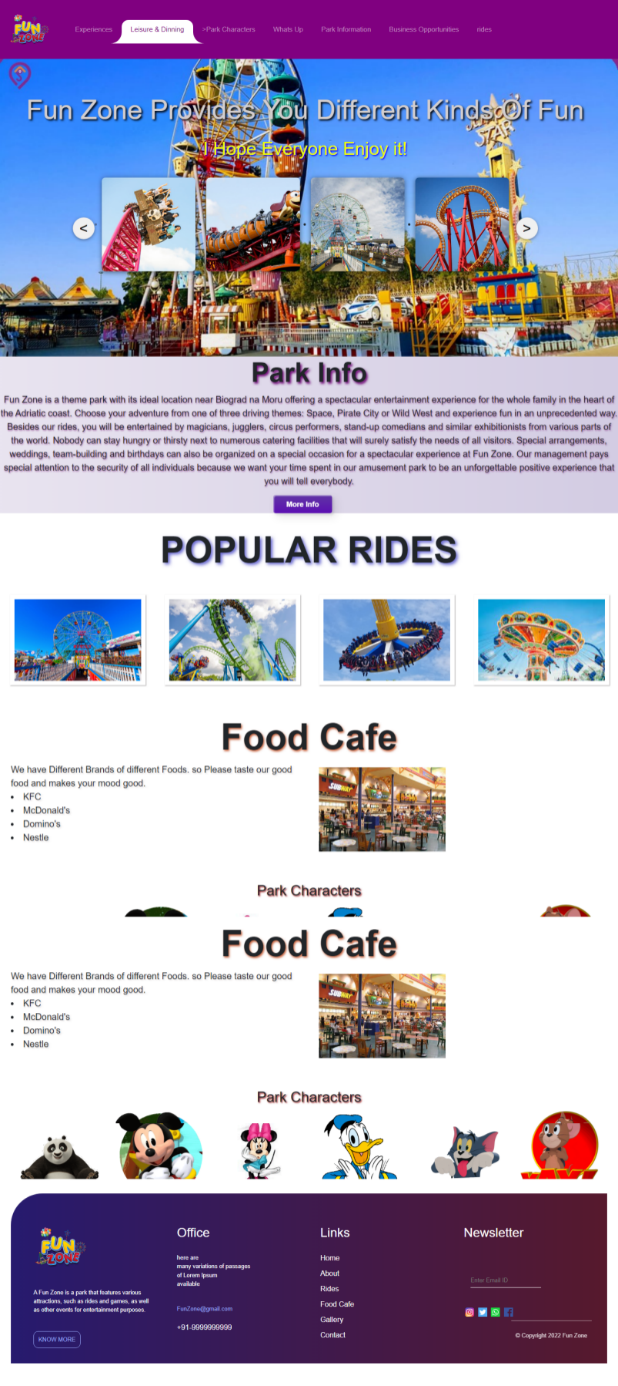

**About Us**

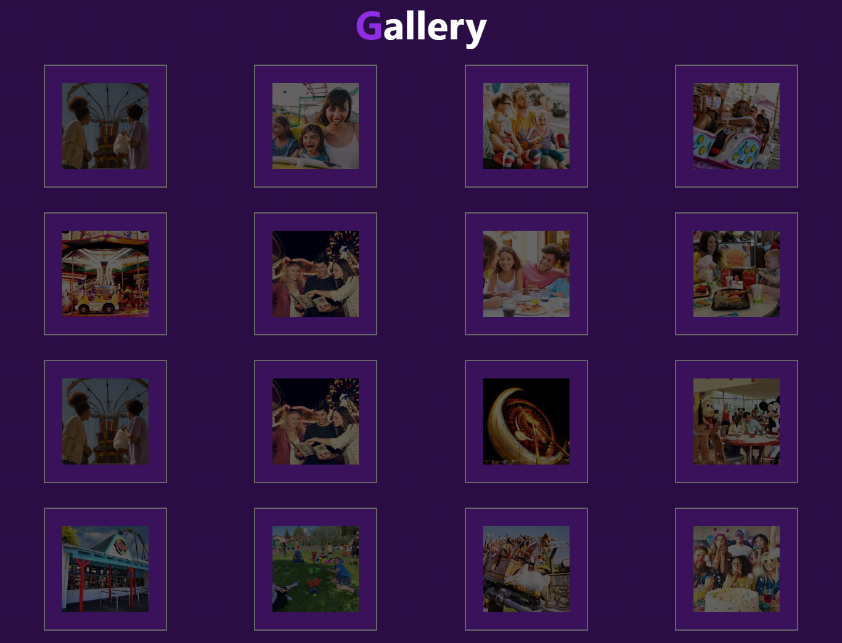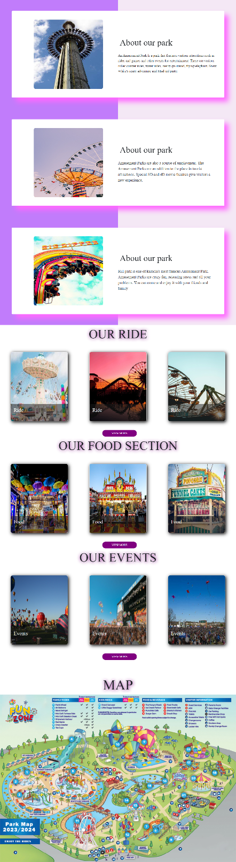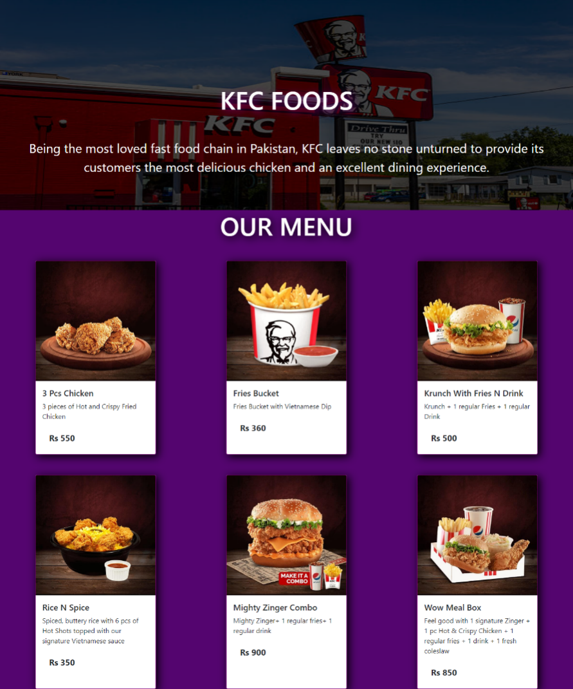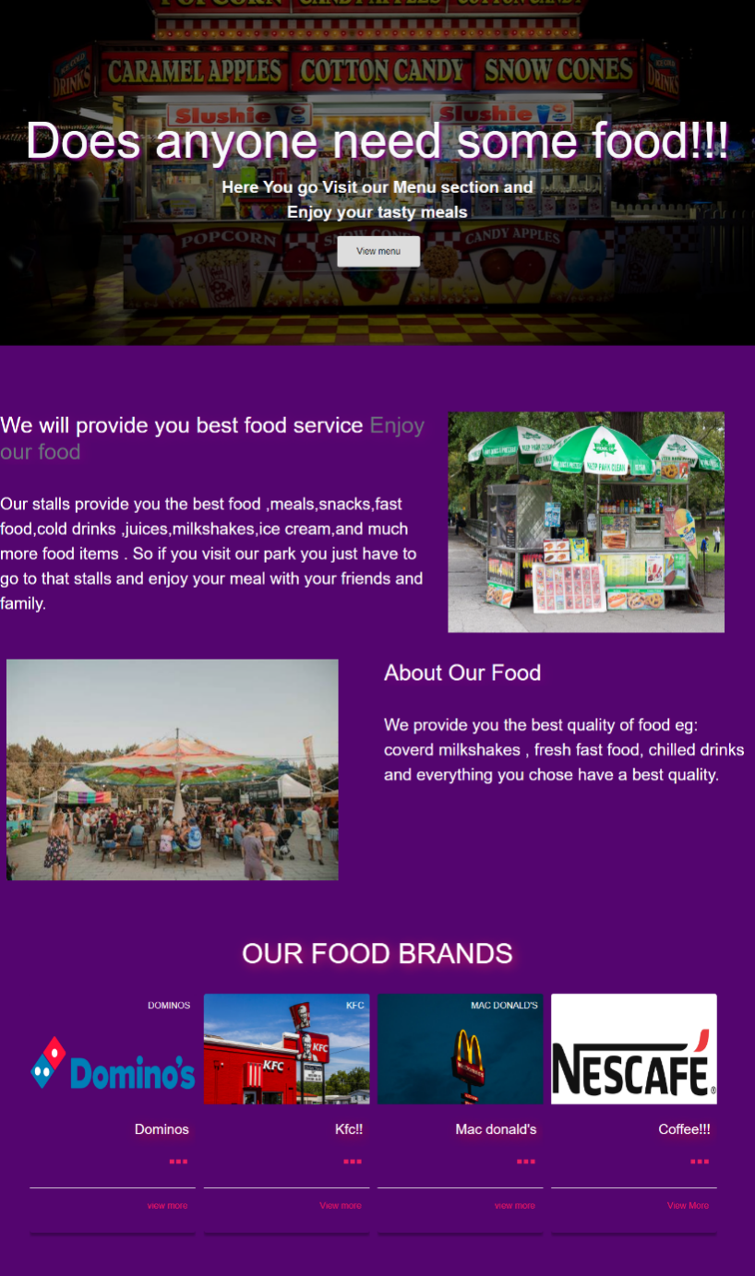

**Gallery**

**Leisure & Dinning**

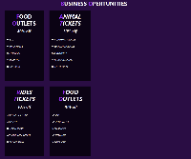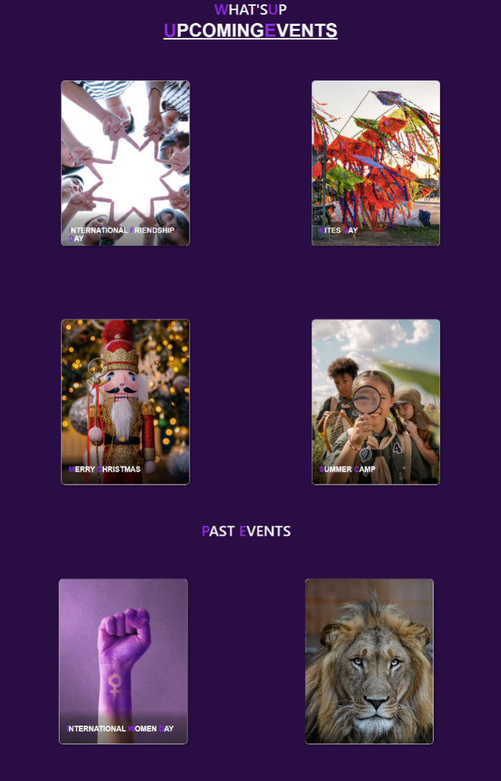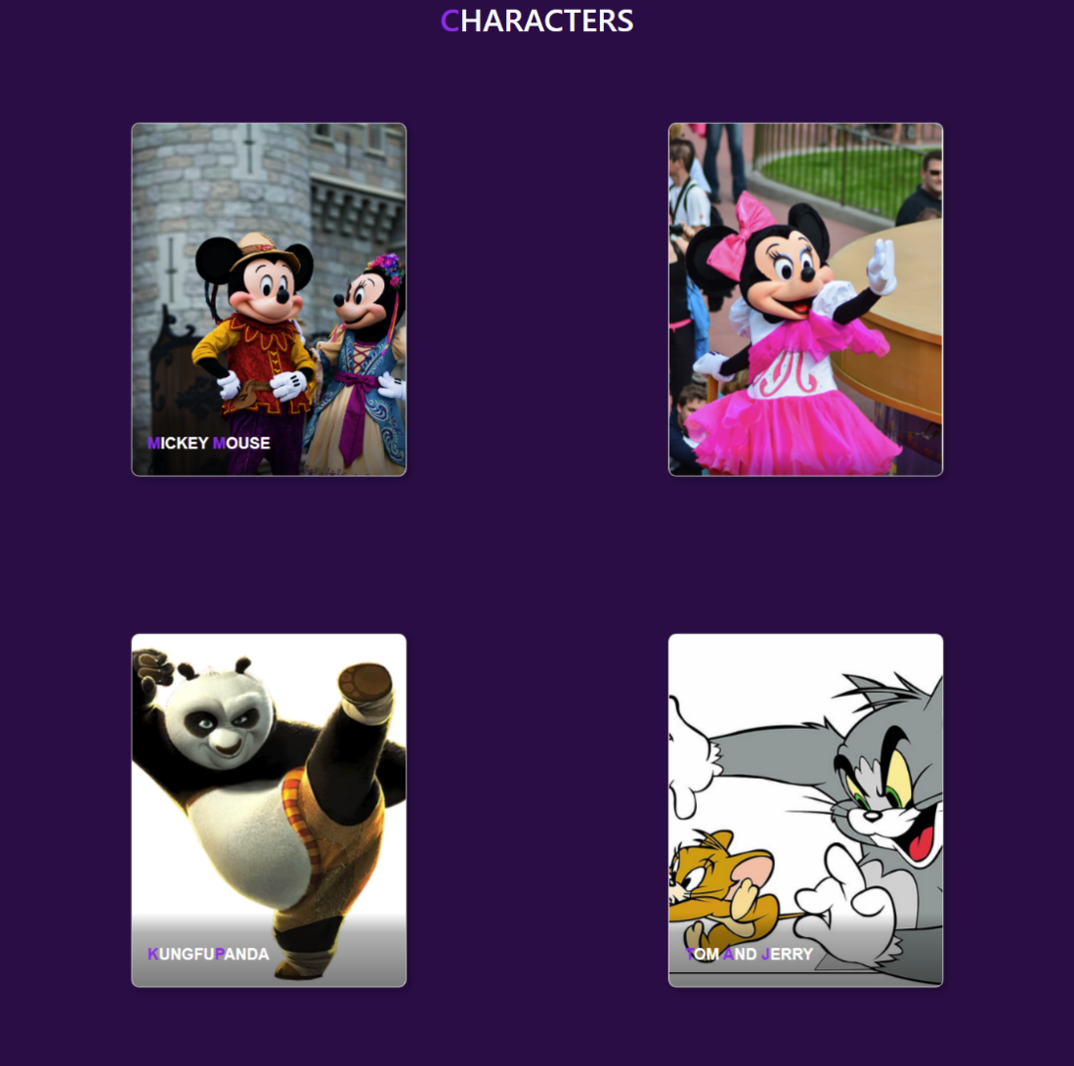

**Business**

**Opportunities**

**Characters**

**Whats Up**

**HARDWARE/ SOFTWARE REQUIREMENTS**

**Hardware**

* A minimum computer system that will help you access all the tools in the courses is a Pentium 166 or better
* 64 Megabytes of RAM or better

**Software**

* Notepad/HTML editor
* Dreamweaver
* IE 5.0/ Netscape 6.0

***THANK YOU***